DASHBOARD DESIGN
Field | Details
Date | 20-Aug-2026 TO 22-Aug-2026
Team ID | Individual
Project Name | Global AI Adoption in Education
Maximum Marks | 5 Marks
Activity 1: Interactive and Visually Appealing Dashboard
The Global AI Adoption in Education Tableau dashboard is designed to provide a clear and interactive view of AI adoption across countries, regions, schools, students, and teachers.
Dashboard Design Principle | Implementation in My Tableau Dashboard
Clear and Intuitive Layout | Dashboard components are arranged in a structured layout with KPIs and visualizations positioned for easy understanding.
Use Appropriate Visualizations | Bar charts, line charts, maps, KPI cards, and comparison charts are used according to the type of analysis required.
Colour and Theming | A consistent colour theme is used to differentiate AI adoption categories and make important values easy to identify.
Interactive Filters and Slicers | Filters allow users to explore AI adoption based on relevant dimensions such as country, region, year, and other available categories.
Drill-Down  Capabilities | Users can explore detailed information from broader regional/country-level analysis where applicable.
Responsive Design | Dashboard elements are organized to maintain readability and usability across different screen sizes.
Custom Visuals and Icons | KPI cards and visual elements are used to make important AI adoption indicators more noticeable.
Use of Infographic | Charts and graphical elements present complex AI adoption information in a simple and understandable form.
Major Outcomes from the Dashboard
- Overall AI Adoption: The dashboard provides an overview of AI adoption levels in the education sector through KPI cards and visualizations.
- Global Comparison: The country-wise map helps identify countries with relatively higher and lower AI adoption.
- Student vs. Teacher Usage: The dashboard compares AI usage between students and teachers, highlighting differences in adoption.
- Regional School Adoption: Region-wise analysis helps identify regions with higher and lower school AI adoption.
- Rural vs. Urban Gap: The dashboard shows differences in AI usage between rural and urban areas and helps identify the digital adoption gap.
- AI Tool Adoption: The leading AI tool visualization identifies the most commonly used AI tools in education.
- Daily AI Usage: Country-wise average daily usage helps identify countries with higher AI usage intensity.
- Year-wise Trends: The dashboard shows how school, student, and teacher AI adoption changes over time.
- Interactive Analysis: Tableau filters and interactive features allow users to explore the data according to their requirements.
- Decision Support: The dashboard converts raw education and AI data into visual insights that can support education planning and AI adoption decisions.

DASHBOARD NO 1:
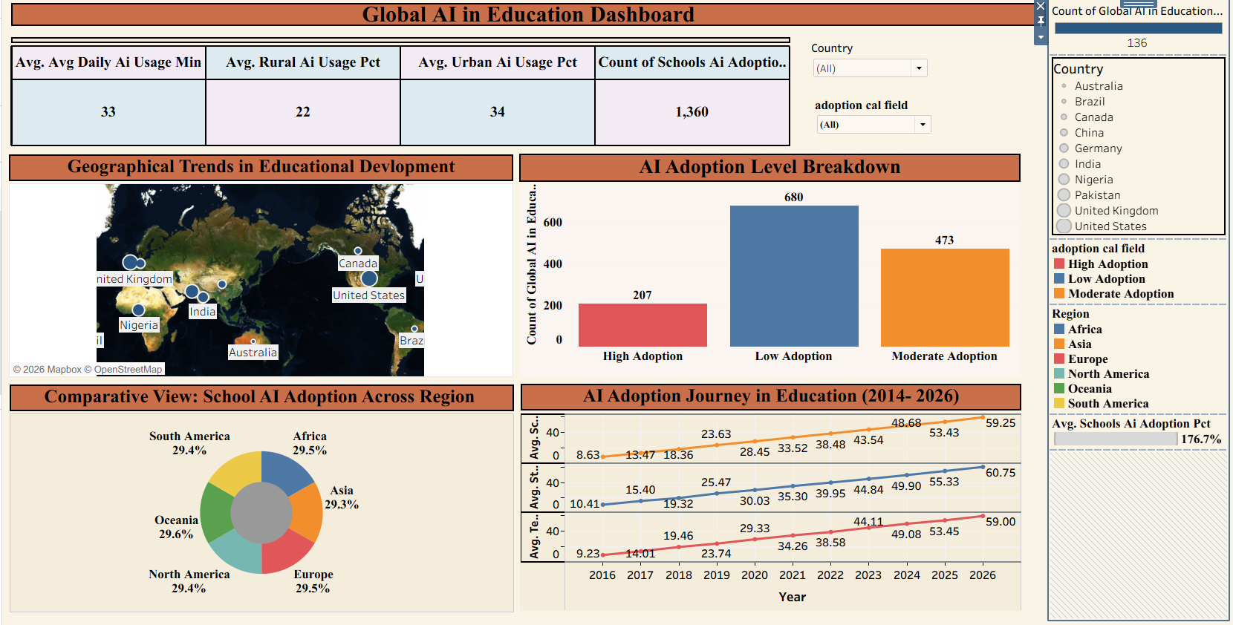

DASHBOARD NO 2 :
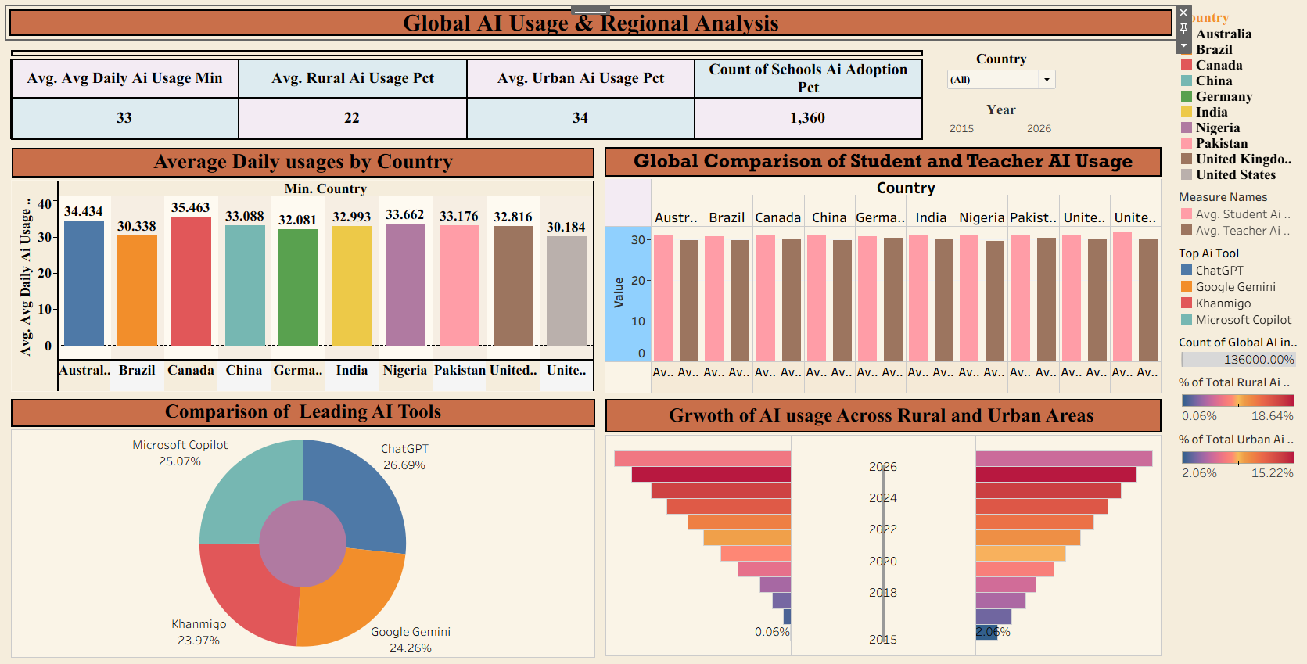

Activity 2: Publish Dashboard on Tableau Public
Tableau Public Dashboard Link:
https://public.tableau.com/app/profile/shreyash.mhettar/viz/GlobalAIAdoptioninEducationDashboard2/Dashboard2

